Wiring Guide for Edison-based Robot

Before proceeding with this guide, be sure to

* Review how a breadboard works
* Ensure the GROVE breakout board is securely attached to the Edison board

**3**

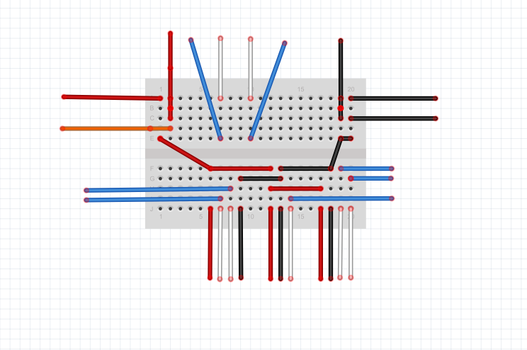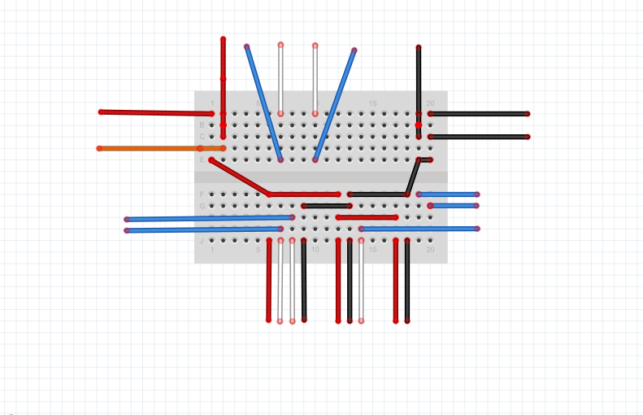

**2**

**2**

**1**

**1**

**7**

**7**

**8**

**5**

**6**

**8**

**6**

**4**

Above is the diagram for the basic breadboard wiring setup with numbered steps.

Here is the color-coded key for the diagram:

**RED wires**: 5V Power

**ORANGE wires:** Battery Power +

**BLACK wires**: Ground (COM)

**WHITE wires**: Sensor Signal wires

**BLUE wires**: Edison I/O wires

Below are the steps for wiring the sensors and motors on the robot to the Edison breakout board.

Step 1:

Connect power wires from Edison to the breadboard as shown in the diagram

The RED wire should be connected to the 5V output on the Edison board

The ORGANCE wire should connect to the battery pack’s power output (red cable)

The BLACK wire should be connected to the GND output on the Edison board

The second BLACK wire should be connected to the battery pack’s ground cable (black)

Step 2:

Connect the RED and BLACK outputs of the motors to the breadboard.

Step 3:

Connect digital pins **5** and **6** from the Edison to the breadboard.

Connect the WHITE output from the motors to the breadboard in the same row.

*Note: Pin 5 is for the left motor, and pin 6 is for the right motor.*

Step 4:

Connect the 4 outputs of the Ultrasonic Sensor to the bottom side of the breadboard.

Step 5:

Connect digital pins **12** and **13** to the same column as the WHITE outputs of the ultrasonic sensor.

*NOTE: Pin 12 is for the ECHO output, and pin 13 is for the TRIG output.*

Step 6:

The touch sensor has 2 outputs: **COM**, **NO**, and **NC**.

Connect the touch sensor to the breadboard. The **NO** output will connect to ground (BLACK).

Connect digital pin **2** to the same column as the **NC** input.

Connect the **COM** output to the power (RED input from the Edison).

Step 7:

Connect the RED and BLACK wires from the top half of the breadboard to the bottom half, to share the power and ground sources.

Step 8:

The LCD Screen has 4 inputs: VCC, GND, SDA, SCL.

Connect the BLUE wires from the Edison to the SDA and SCL outputs (above Digital pin 13)

Connect the LCD Cable to the LCD screen

Connect the BLACK cable to the GND

Connect the RED cable to the 5V power supply

Connect the WHITE cable to the SDA input

Connect the YELLOW cable to the SCL input